SAB1:
Step1 : Created Repository to github and cloned it in local machine using terminal.
Command used-
$git clone https://github.com/DhanashreeKharade451/version-control-simulation-DhanashreeAjay.git
Cloning into 'version-control-simulation-DhanashreeAjay'...
warning: You appear to have cloned an empty repository.
PS C:\Users\khara\OneDrive\Desktop\2025RTT74>
Step2. :
created feature/header branch and added header in index.html file
and committed changes.
$code index.html
$ $ git add index.html
$ git commit -m "added header to header branch"
[feature/header (root-commit) 12658f1] added header to header branch
1 file changed, 13 insertions(+)
create mode 100644 index.html
*****************
step 3:
created branch feature/footer added footer in feature/footer branch
added changes and committed.
$ git commit -m "added header to header branch"
[feature/header (root-commit) 12658f1] added header to header branch
1 file changed, 13 insertions(+)
create mode 100644 index.html
*********************
step4:
checkout to feature/header branch and added footer section in this branch as well.
$ git checkout feature/header
Switched to branch 'feature/header'
$ git add .
$ git commit -m "added footer from feature/footer"
[feature/header 7d2b0f0] added footer from feature/footer
1 file changed, 4 insertions(+)
*********************
Step5:
Checkout to main branch merged feature/footer branch to main
$ git checkout main
Switched to branch 'main'
Your branch is based on 'origin/main', but the upstream is gone.
(use "git branch --unset-upstream" to fixup)
$ git merge feature/footer
Updating 12658f1..e5fa82b
Fast-forward
index.html | 3 +++
1 file changed, 3 insertions(+)
Step6:
Merged feature/header branch to main ,got merge conflict and resolved it.
Added changes and committed.
$ git merge feature/header
Auto-merging index.html
CONFLICT (content): Merge conflict in index.html
Automatic merge failed; fix conflicts and then commit the result.
$ git add .
$ git commit -m "Resolved conflict"
[main 2e8c97c] Resolved conflict

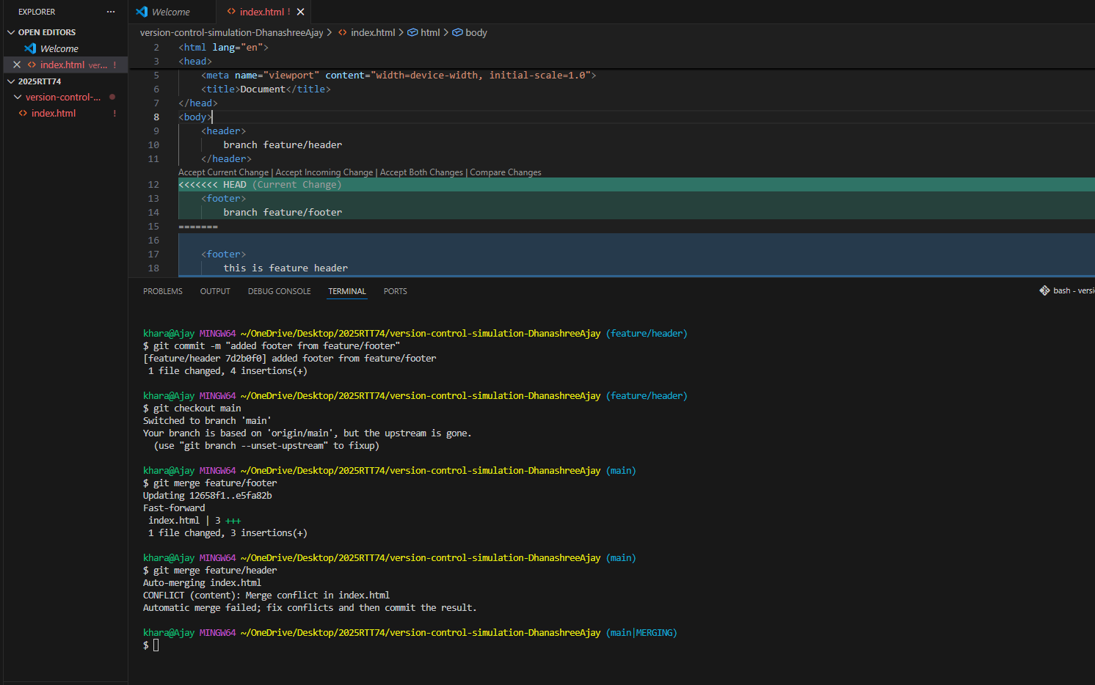

Step 7:
Created branch review/main added some changes and pushed to github .
added some more changes to main . and pull the code from main branch to “review main” branch on github by creating “ pull request”

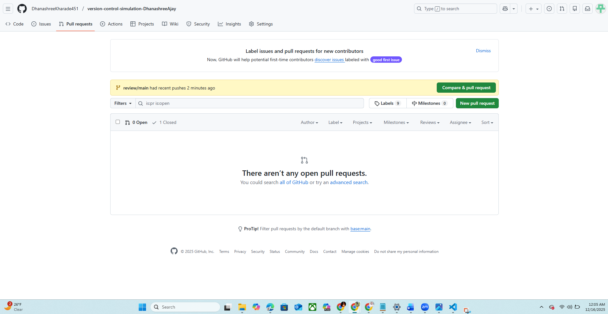

Step8:
merged pull request successfully on github:
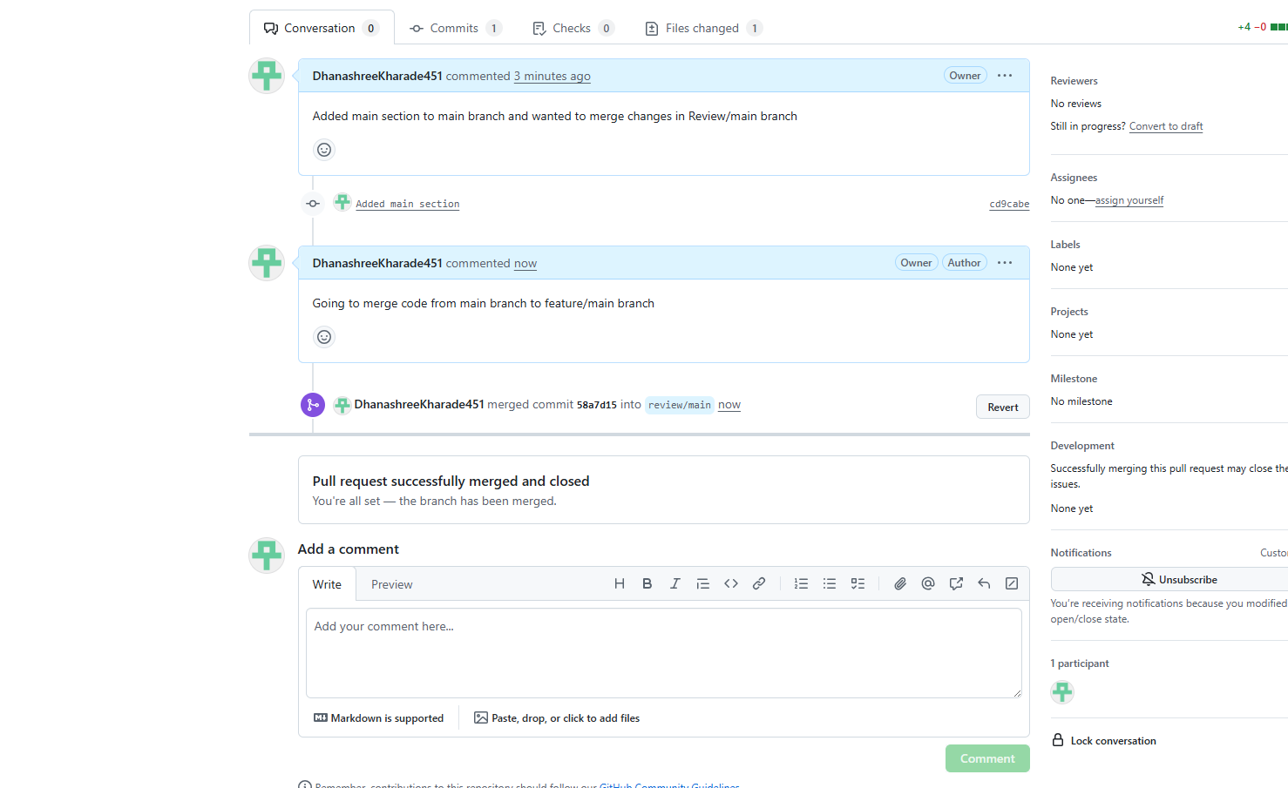
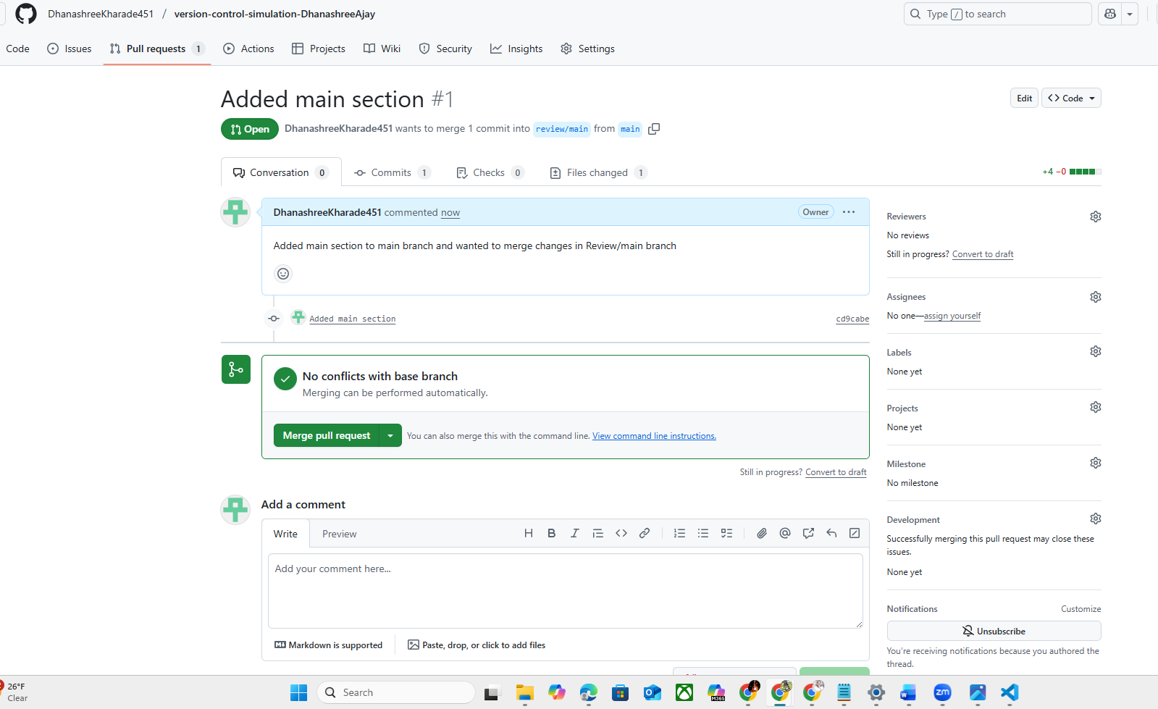

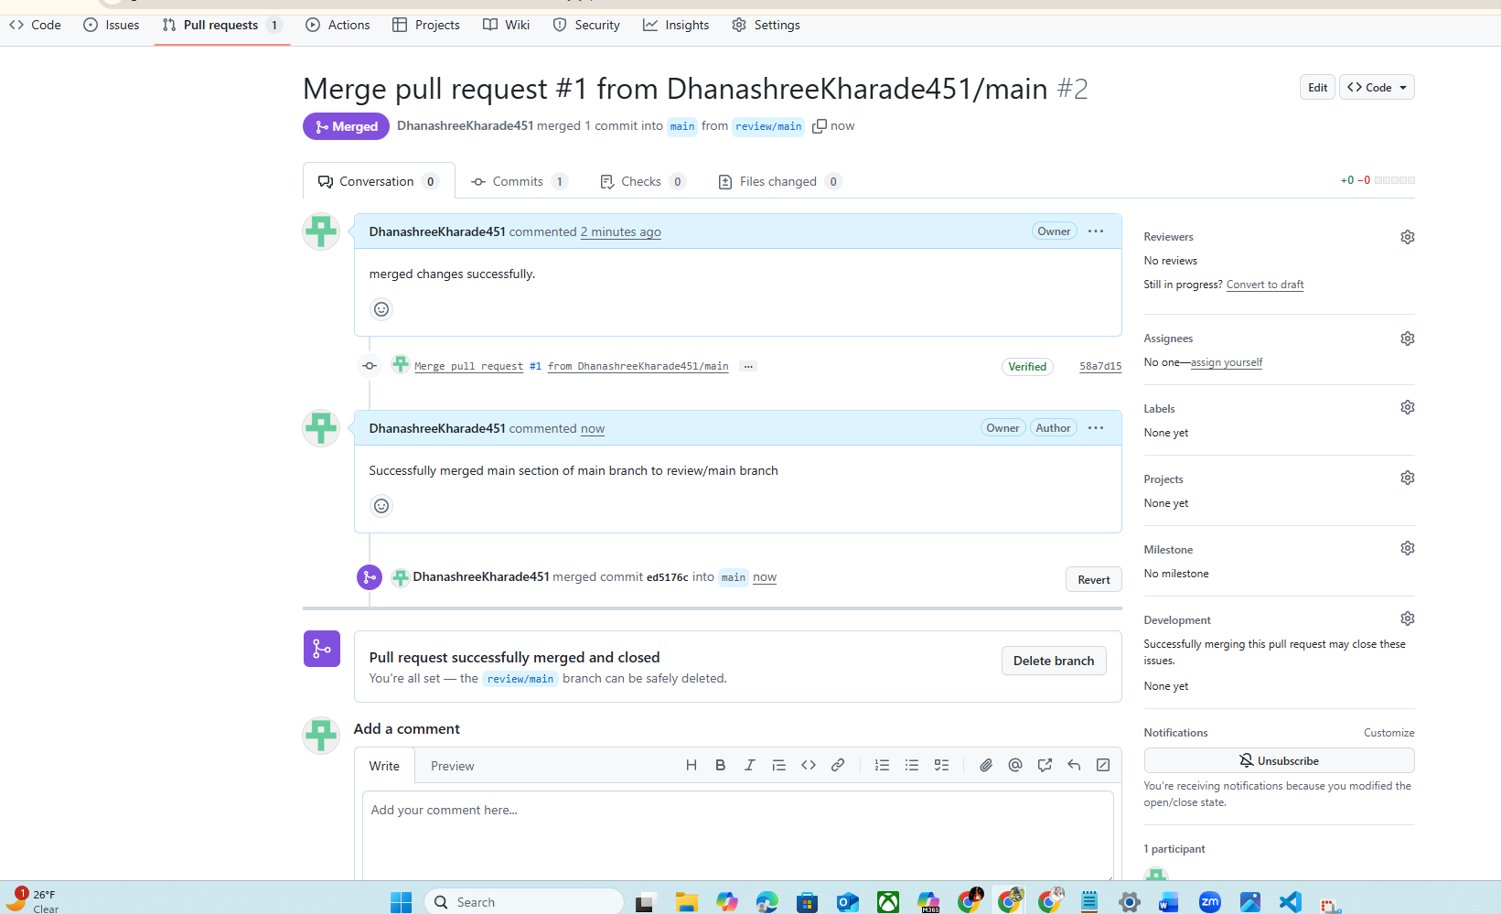

Step9:
On local machine,Still need to merge main branch to “review main” branch
merged branch using git pull command
$ git pull origin main
From https://github.com/DhanashreeKharade451/version-control-simulation-DhanashreeAjay
* branch main -> FETCH_HEAD
Auto-merging index.html
Merge made by the 'ort' strategy.
index.html | 4 ++++
1 file changed, 4 insertions(+)

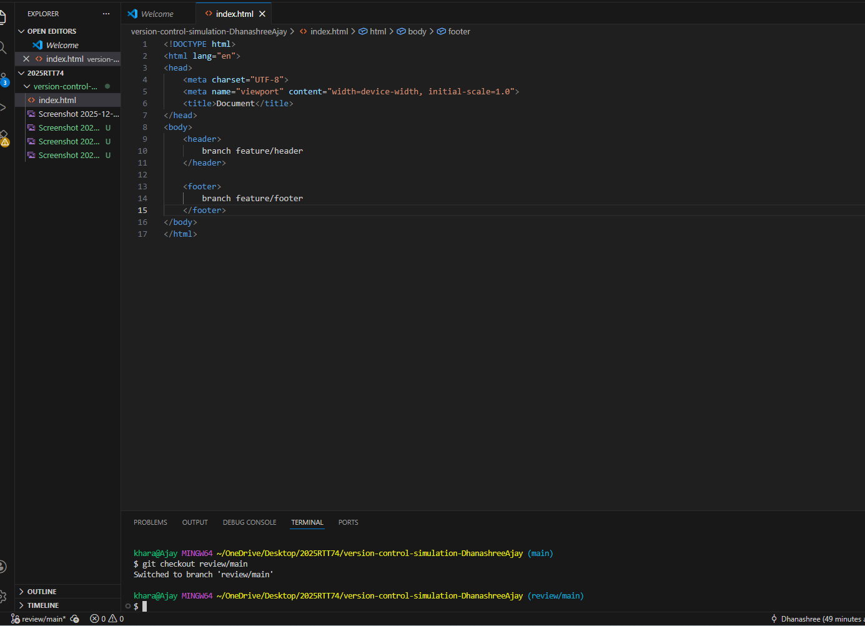
Merged code on local review/main branch:
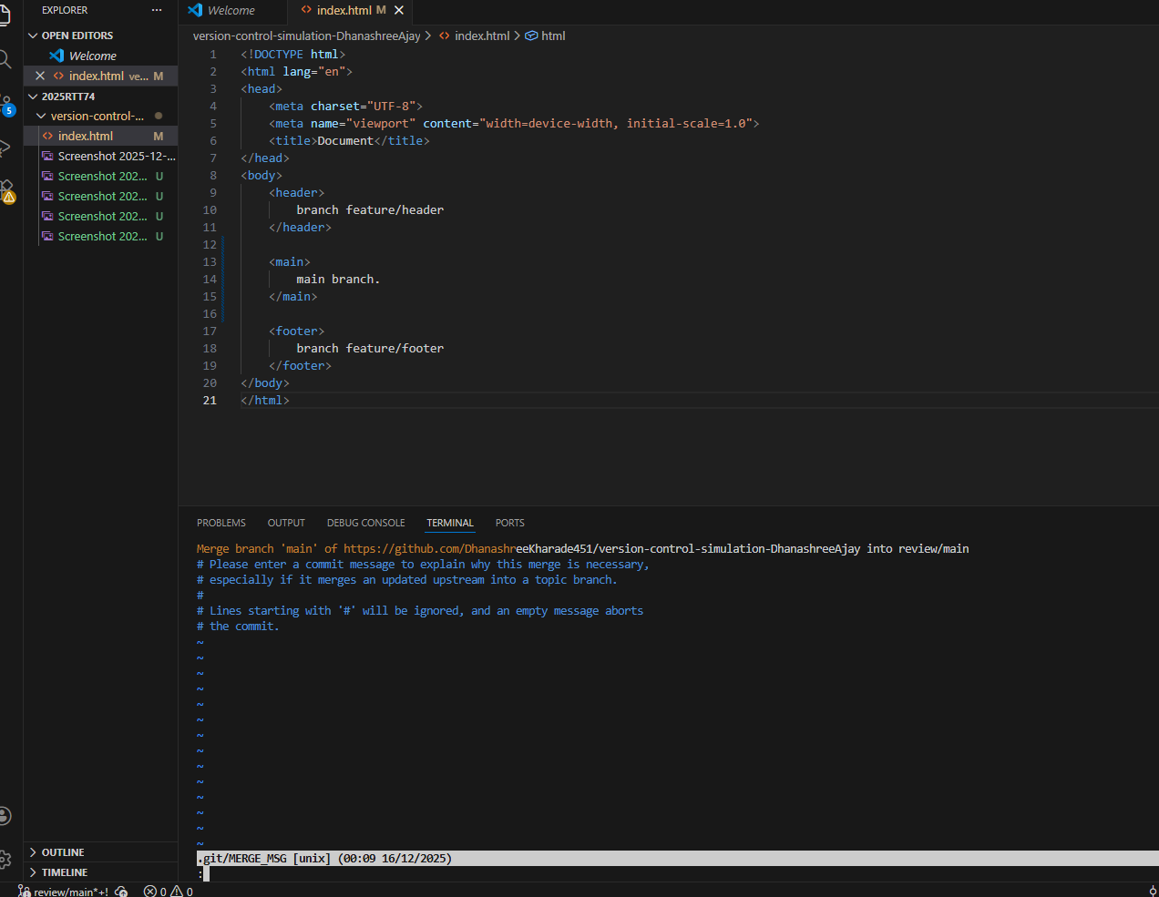

Thank you.

